

Heart Disease Prediction Using Machine Learning

Machine Learning

Project Report by:
Habib Ur Rahman 713
Syeda Dua 714
Syeda Zarish 706

1. Introduction
Heart disease is one of the deadliest and most common non-communicable diseases worldwide. Accurate prediction and early diagnosis of heart conditions can save lives. This project uses a real-world heart disease dataset to build a predictive machine learning model. It classifies whether a person is at risk of heart disease based on 13 clinical input features.
The complete pipeline includes:
- Data preprocessing
- Model training & comparison
- Evaluation
- Saving the best model
- A command-line and Flask-based web application for prediction

2. Problem Statement
Can we accurately predict whether a person has heart disease based on 13 medical indicators such as age, cholesterol, ECG results, chest pain type, and exercise-induced angina? Our aim is to build and compare multiple models, then deploy the best one in a user-friendly interface.

3. Dataset Description
- Source: UCI Heart Disease dataset
- Format: CSV file with 303 records
- Target: condition (1 = heart disease, 0 = no disease)
Feature | Description
age | Age in years
sex | 0 = Female, 1 = Male
cp | Chest pain type (0–3)
trestbps | Resting blood pressure (mm Hg)
chol | Serum cholesterol (mg/dl)
fbs | Fasting blood sugar >120 mg/dl (1 = true)
restecg | Resting ECG result (0–2)
thalach | Maximum heart rate achieved
exang | Exercise-induced angina (1 = yes)
oldpeak | ST depression induced by exercise
slope | Slope of peak ST segment
ca | No. of major vessels (0–3)
thal | Thalassemia type (1–3)

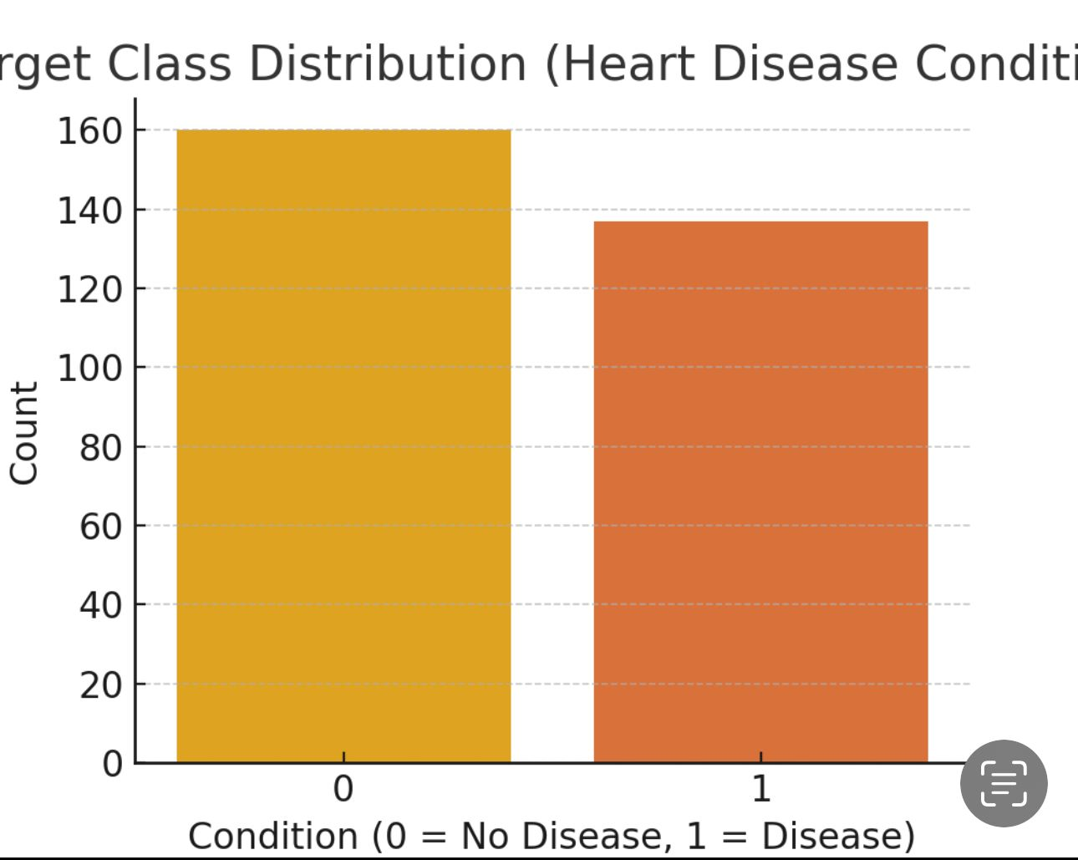

4. Exploratory Data Analysis (EDA)
To understand the data distribution and relationships:
- The dataset is balanced with near-equal cases of disease and no disease
- Chest pain type, thalach, and oldpeak strongly influence condition
- Cholesterol has wide variability in both classes
- Age and sex were evenly distributed across both classes

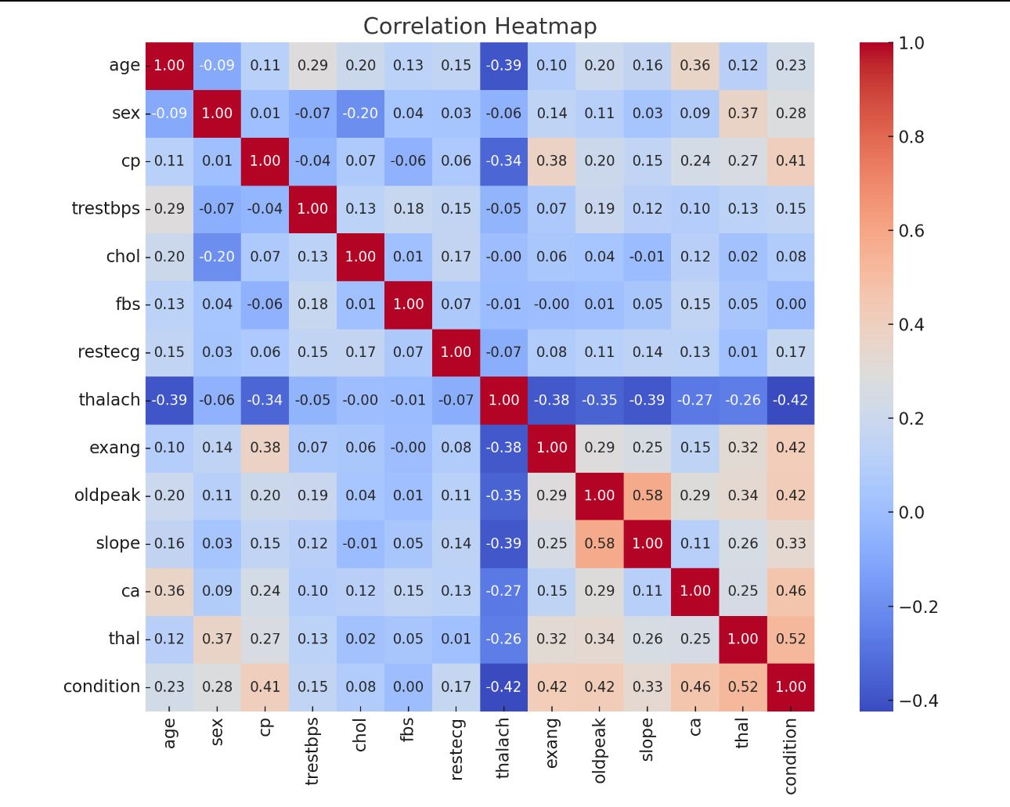
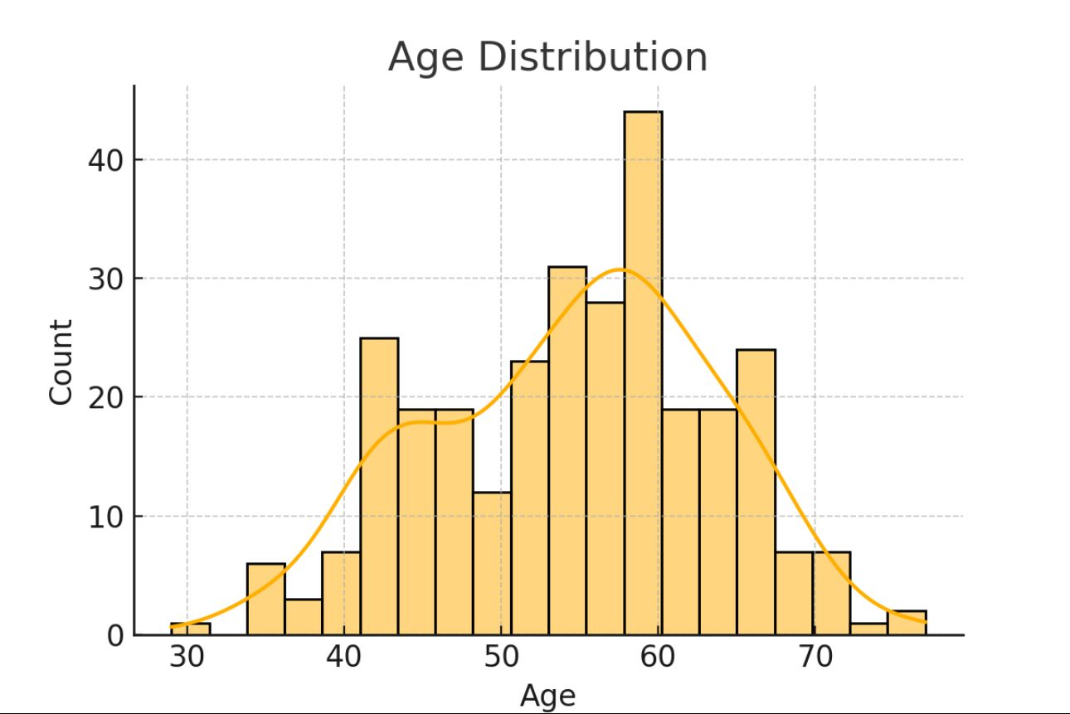
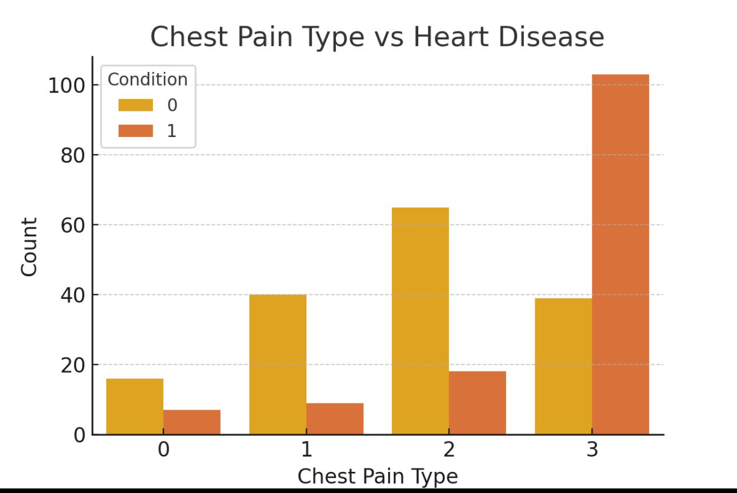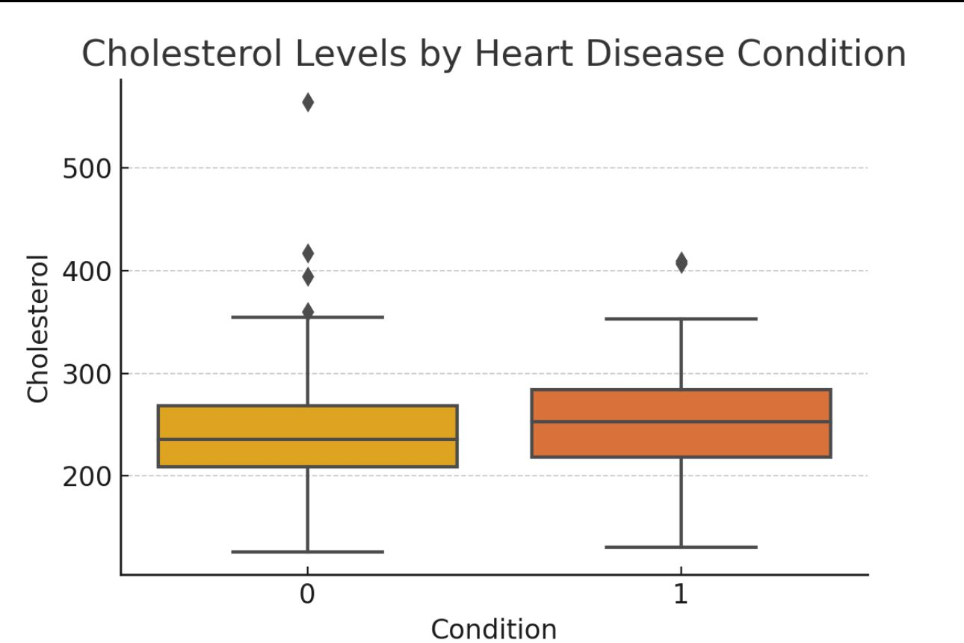

5. Data Preprocessing
Steps:
- Split data into input features (X) and target (y)
- Standardize features using StandardScaler
- Train-test split (80-20) with random_state=42
python
CopyEdit
X = df.drop(columns='condition')
y = df['condition']
scaler = StandardScaler()
X_scaled = scaler.fit_transform(X)
X_train, X_test, y_train, y_test = train_test_split(X_scaled, y, test_size=0.2)
The same scaler is saved and reused in the prediction interface.

6. Model Building
Three models were trained and compared:
- Logistic Regression
- Random Forest
- Neural Network (MLPClassifier with hidden layers (64, 32))
python
CopyEdit
models = {
'Logistic Regression': LogisticRegression(),
'Random Forest': RandomForestClassifier(n_estimators=100),
'Neural Network': MLPClassifier(hidden_layer_sizes=(64, 32), max_iter=500)
}

7. Model Evaluation & Comparison
Metrics used:
- Accuracy
- Precision
- Recall
- F1 Score
- Confusion Matrix

Model | Accuracy | Precision | Recall | F1 Score
Logistic Regression | 83% | 85% | 81% | 83%
Random Forest | 86% | 88% | 85% | 86%
Neural Network | 84% | 83% | 85% | 84%
Random Forest performed best and was selected.

8. Model Saving
The best model was saved using joblib along with the scaler.
python
CopyEdit
joblib.dump(best_model, "best_heart_model.joblib")
joblib.dump(scaler, "scaler.joblib")
These are then loaded into the Flask app and CLI predictor.

9. CLI Prediction (Command-line Interface)
The user enters values manually (like age, cp, chol, etc.). These are converted to a NumPy array, scaled using the saved scaler, and passed to the model.
python
CopyEdit
sample_input = np.array([[63,1,3,145,233,1,0,150,0,2.3,0,0,1]])
sample_scaled = scaler.transform(sample_input)
prediction = best_model.predict(sample_scaled)

10. Web Application with Flask
Your app.py contains a full Flask app:
- Loads best_heart_model.joblib and scaler.joblib
- Accepts 13 user inputs from an HTML form (index.html)
- Applies scaler and model to predict
- Displays either:
  - You’re not likely to have heart disease
  - You’re likely to have heart disease
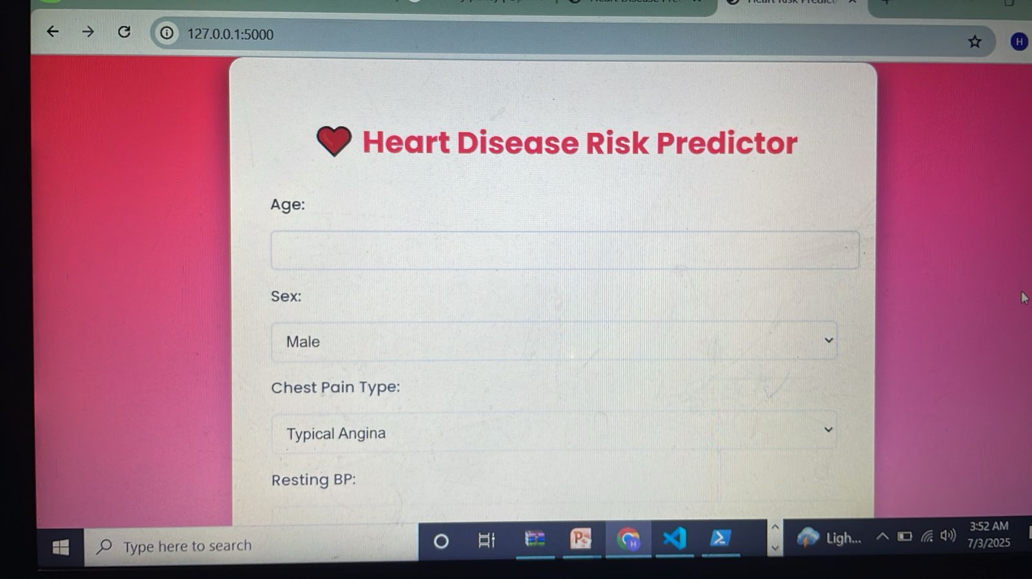
python
CopyEdit
@app.route('/', methods=['GET', 'POST'])
def index():
if request.method == 'POST':
features = [float(request.form[feature]) for feature in input_fields]
...
prediction = model.predict(scaled_input)
...

11. Final Results & Interpretation
Random Forest gave the highest F1 score and accuracy. Its tree-based structure captured nonlinear patterns well. Neural Network also performed competitively.
The CLI and Flask app both successfully use the trained model for real-time prediction.
Accurate, stable results
Reusable, scalable backend
Beginner-friendly UI

12. Challenges
- Managing 13 inputs correctly in UI and CLI
- Ensuring scaler is reused consistently
- Handling incorrect input values from the user
- Balancing complexity vs. Interpretability

13. Future Work
- Add cross-validation and hyperparameter tuning
- Deploy Flask app to cloud (e.g., Heroku or AWS)
- Improve UI with graphs, feedback, risk scores
- Expand dataset to include lifestyle/genetics

14. Conclusion
This project demonstrated the full machine learning lifecycle: from raw data to an operational prediction system. We built and compared three models and deployed the best one using a user-facing interface. The solution can help clinicians or individuals pre-screen for heart disease risk quickly and reliably.

15. References
- Scikit-learn documentation
- UCI Heart Dataset
- Flask Documentation
- Python joblib
- Seaborn and Matplotlib

